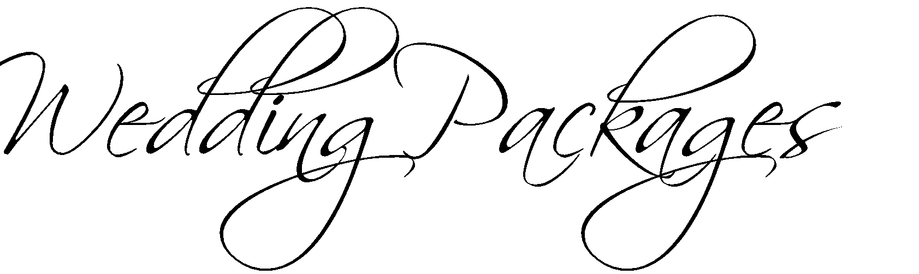

Package A
Eight Hour Room Rental *
Choice of Menu
Assortment of hors d’oeuvres during Cocktail Hour *
Cash Bar Or Add a Five Hours Open Standard Bar, fee applies
Non-Alcoholic Beverages
Three Bottles of Wine
(per table of ten)
Coffee & Tea throughout the evening
Set up and Clean up
White linen & coloured napkins, dinnerware
Chaircovers, Ceiling and Post Swags with Lights Included
Skirted Head Table with Lights, Cake Table, Gift/Guest Book Table
Wireless Microphone and podium for speeches
Event Coordinator onsite

Package B
Eight Hour Room Rental *
Charcuterie Board *
Choice of Menu
Five Hour Standard Open Bar
Assortment of hors d’oeuvres during Cocktail Hour *
Late Night Food Option- (Choose One) Pizza or Poutine*
One Bottle of Sparkling Wine on Each Table of Ten People
Non-Alcoholic Beverages
Three Bottles of Wine (per table of ten)
Coffee & Tea throughout the evening
Set up and Clean up
White linen & coloured napkins, dinnerware
Chaircovers, Ceiling and Post Swags with Lights Included
Skirted Head Table with Lights, Cake Table, Gift/Guest Book Table
Wireless Microphone and podium for speeches
Event Coordinator onsite
Add per person to Upgrade to Premium Bar

Email for more information about packages.

